33.Write a Python program to draw a scatter plot with empty circles taking a
random distribution in X and Y and plotted against each other.
Program:
import matplotlib.pyplot as plt
import numpy as np

x = np.random.rand(50)
y = np.random.rand(50)

plt.scatter(x, y, facecolors='none', edgecolors='blue')
plt.xlabel("X")
plt.ylabel("Y")
plt.title("Scatter Plot with Empty Circles")
plt.show()

Output:
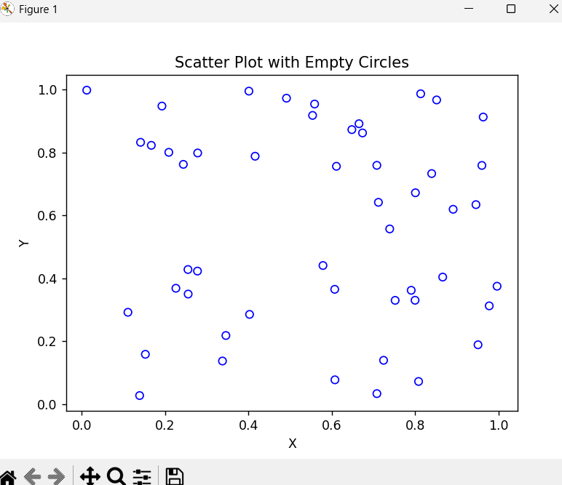

34.Write a Python program to draw a scatter plot using random distributions to
generate balls of different sizes.

Program:
import matplotlib.pyplot as plt
import numpy as np

x = np.random.rand(50)
y = np.random.rand(50)
sizes = np.random.randint(20, 300, 50)

plt.scatter(x, y, s=sizes)
plt.xlabel("X")
plt.ylabel("Y")
plt.title("Scatter Plot with Different Ball Sizes")
plt.show()

Output:
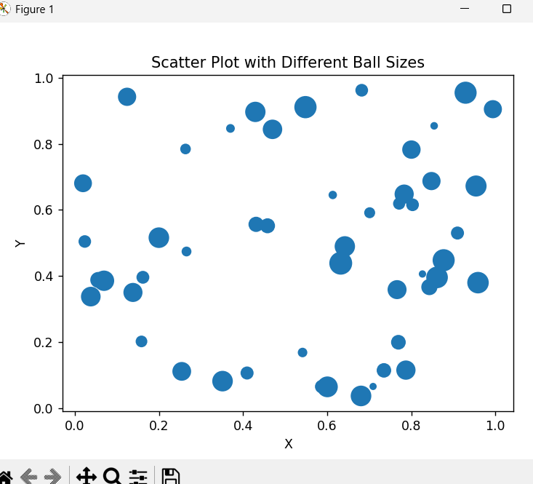

35.Write a Python program to draw a scatter plot comparing two subject
marks of Mathematics and Science. Use marks of 10 students.
Program:
import matplotlib.pyplot as plt

math_marks = [88, 92, 80, 89, 100, 80, 60, 100, 80, 34]
science_marks = [35, 79, 79, 48, 100, 88, 32, 45, 20, 30]
marks_range = [10, 20, 30, 40, 50, 60, 70, 80, 90, 100]

plt.scatter(marks_range, math_marks, label="Mathematics")
plt.scatter(marks_range, science_marks, label="Science")

plt.xlabel("Marks Range")
plt.ylabel("Marks")
plt.title("Mathematics and Science Marks")
plt.legend()
plt.show()

Output:
